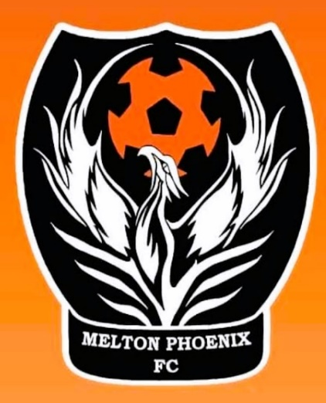

Photography / social media consent
Melton Phoenix Football Club believes it is important to acknowledge the accomplishments and successes of all our members, one of the ways we do this is to publish photos/ videos to our social media sites/ websites/ or promotional pamphlets.
We take the issue of child safety very seriously this includes the images in our care. Our duty is to all club members, this form is to ensure that the safety of all club members is considered, and privacy is paramount.
For this reason, we have implemented the following guidelines:
- We ask parental consent for the club to take and use photographs of their children and for permission to use on all social media/ website to promote the club and the players.
- Photographs and videos will always be taken in the presence of the team coaches and team mangers.
- We will only use team photographs and action photographs on our website and social media.
- Action and individual photographs will only be used with the individual parental consent, prior to the inclusion on the club website/ social media.
I have read the conditions of use and I do / not consent to my child / children images being used. If there is any change to my decision I will inform the club immediately.

Name of child/ children: ________________________________________________________
Name of parent/ guardian: _______________________________________________________
Signature: _____________________________ Date: ___________________________________

